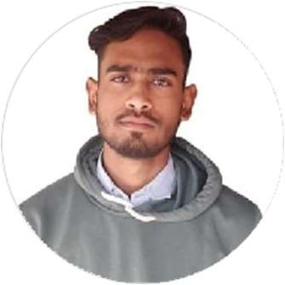
Rahul Saxena
Student
Passionate and driven undergraduate student with a thirst for knowledge and a strong work ethic. Committed to continuous growth and eager to contribute my enthusiasm, creativity, and dedication to any project or team.

EDUCATION

Graduation(BCA)

GITM lucknow
08/2022 - Present, Lucknow

Intermediate

Kendiya vidyalaya OEF
04/2020 - 03/2021, kanpur

Highschool

Kendriya Vidyalaya OEF
04/2018 - 03/2019, Kanpur

WORK EXPERIENCE
SKILLS

C programming
Java
HTML
python

Kotlin
HTML
JavaScript

PERSONAL PROJECTS
Quiz Website, Calculator, Personal Portfolio

ORGANIZATIONS
none

N/A

CERTIFICATES
Participated in Debugging Competition and problem solving at Goel institute .

LANGUAGES
Hindi
Limited Working Proﬁciency

English
Limited Working Proﬁciency

rahulsaxena23012004@gmail.com
7905157775
kanpur, India
linkedin.com/in/rahulsaxena2004
github.com/RaHuL79051

INTERESTS
Application Development
Web Design

